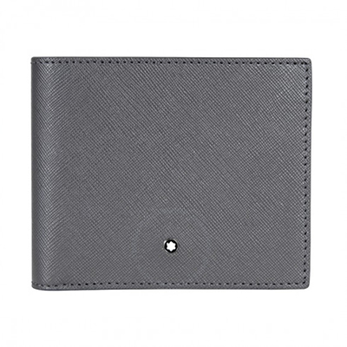

MontBlanc Sartorial 8CC Wallet- Grey

PRODUCT DETAILS

**A Montblanc Sartorial wallet crafted in grey Italian calfskin leather featuring eight credit card slots, two bill compartments, and two additional pockets. Dimensions: 4.1" x 3.7".**